**Can you build a triangle?**

*Measure each of the pencils and record their measurements below.*

*Which combinations of the pencils can build a triangle? Why?*

**Clock Challenge**

*Draw a diagram to illustrate*

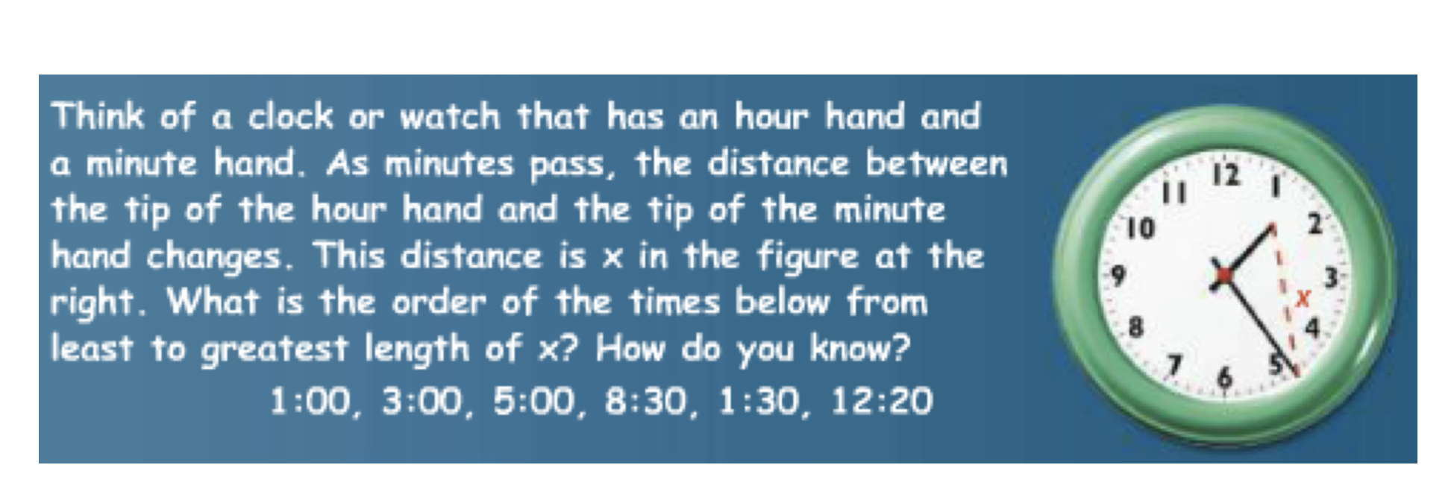

**Unit 4 Regents Problems**

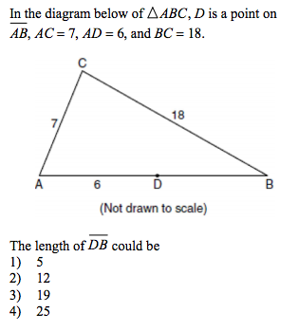

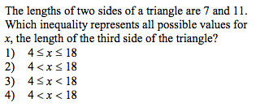

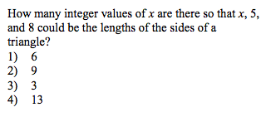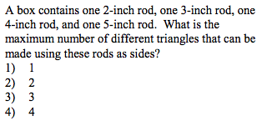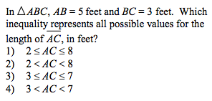

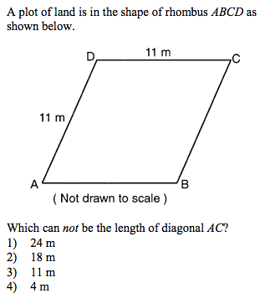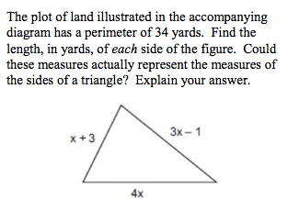

**Create a Midsegment Problem for the next group to solve**

**Create a Medians/Centroid Problem for the next group to solve**

**Create an Altitude/Orthocenter Problem for the next group to solve**